**Article Title:** Deploying Community Paramedics to Address Medication Complexity At Home

**Full Article:** <https://www.healthaffairs.org/do/10.1377/hblog20190129.181994/full/>

**Published:** January 30, 2019

**Article Summary:** Addressing medication complexity requires a holistic approach, which should include deploying providers, such as community paramedics, in new or expanded roles. Barriers related to medication complexity may include prescription drugs being stored incorrectly, patients taking expired medications or over-the-counter supplements that have not been reported to their provider(s), or patients having difficulties adhering to complicated medication instructions.

One promising community paramedicine model that is beginning to show results for individuals with complicated medication routines is ThedaCare's community paramedicine pilot program in eastern Wisconsin. Through funding from the Gordon and Betty Moore Foundation's Community Management of Medication Complexity Innovation Lab, ThedaCare expanded the paramedicine pilot to address medication complexity. With this legislative buy-in, the role of community paramedics is strengthened and officially recognized as a needed addition to solving local health care issues, including medication complexity and the myriad problems it creates for patients and providers. As recognition of the importance of addressing medication complexity among our most vulnerable populations increases, community-based innovations in medication management will undoubtedly flourish.

**Twitter Query Specifications**

|  |  |  |
| --- | --- | --- |
| Type | Query | # of tweets returned |
| Tweets about Article | Exact phrase:  “Deploying Community Paramedics To Address Medication Complexity At Home”  “'healthaffairs.org/do/10.1377/hblog20190129.181994/full/”  Date Parameter: 1/30/2019 – Unbounded | 21 |
| Tweets about Topic prior to Article | Exact phrase: “Community Paramedic”  Any of these words: Medication, Drug, Medicate  Date Parameter: Unbounded - 1/30/2019 | 30 |

**Prospective Qualitative Analysis (Tweets about article):** After the article was published on Health Affairs, the Health_Affairs Twitter account sent a tweet out with linking to it.

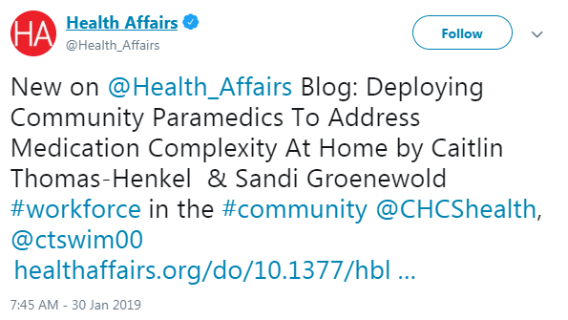

From there, 20 users wrote original tweets, and 21 users retweeted existing tweets about the article. The breakdown of the types of stakeholders writing original tweets are in the table below:

Tabulation of Stakeholder Types (Manually Labeled) Writing Original Tweets

|  |  |
| --- | --- |
| **Stakeholder Type** | **# of users** |
| Individual Practitioner | 6 |
| Healthcare Association | 5 |
| General Public | 3 |
| Healthcare Provider | 3 |
| Individual Researcher | 1 |
| Health Affairs Journal | 1 |
| News Aggregator | 1 |
| **Total** | **20** |

A liitle over half of users (12 of them) simply included the name/title of the article without adding any additional commentary. The remaining 8 users tweeted largely to express support for the practice, though a couple users used the opportunity to criticize other parts of the healthcare system.

Commentary Tweets about Article

|  |  |  |  |
| --- | --- | --- | --- |
| Tweet # | Stakeholder Type | Summary of Sentiment | Full Text of Tweet |
| 1 | Individual Practitioner | Positive Support | Closing the gap on preventable adverse drug events - Kudos @CHCShealth : Health Affairs Blog | Deploying Community Paramedics to Address Medication Complexity at Home http:// bit.ly/2FPCCTn via @CHCShealth |
| 2 | Individual Practitioner | Negative Criticism, believes pharmacists are better suited for this role | Deploying Community Paramedics To Address Medication Complexity At Home http:// disq.us/t/3b0salv #Pharmacistswakeup ! #Pharmacistsprovidecare #ifyoupayparamedicsyoucouldpaypharmacists #pharmacistsarethemedicationexperts |
| 3 | Individual Practitioner | Positive Support | We could not agree more and love the community paramedic program in Durham; we need to work even more closely together. https://www. healthaffairs.org/do/10.1377/hbl og20190129.181994/full/ |
| 4 | General Public | Positive Support | Using community paramedics to prevent some of the 119k annual deaths in the US due to medication errors #HomeVisitingWorks https://www. healthaffairs.org/do/10.1377/hbl og20190129.181994/full â€¦ @CHCShealth @ctswim00 |
| 5 | Individual Researcher | Positive Support | Time for Aussies to step up! Deploying Community Paramedics To Address Medication Complexity At Home | Health Affairs https://www. healthaffairs.org/do/10.1377/hbl og20190129.181994/full/#.XFP1zFg8VnE.twitter â€¦ |
| 6 | General Public | Unclear | Small ball, go to fire station for your pills or better yet, paramedics will just come to you. City Fire Depts are more & more overstaffed as buildings become more fire-resistant. Providing primary/chronic care is a good side business for them to go into. https://www. healthaffairs.org/do/10.1377/hbl og20190129.181994/full/ â€¦ |
| 7 | Healthcare Association | Positive Support | Many of our grantees use Community Health Workers in their efforts to reduce disparities in diabetes. A new pilot employs Community Paramedics to help patients interpret and develop medication schedules by developing a therapeutic rapport w/patients. http:// ow.ly/MiWf50kxxB0 |
| 8 | Individual Practitioner | Positive Support | Unlike a traditional paramedic, whose goal is to quickly triage and process an emergency situation, a community paramedic builds a therapeutic rapport with patients to understand what is going on â€œbelow the surface.â€ http:// bit.ly/2TwTUb0 |

**Retrospective Qualitative Analysis (Tweets about topic prior to article being published):**

Additionally, several articles related to this topic were published prior to this: <https://www.chcs.org/resource/addressing-medication-complexity-through-community-based-strategies/?_lrsc=322dd987-1c4c-4669-8537-aa54967e85bb&utm_source=Elevate&utm_medium=social&utm_campaign=Associates>